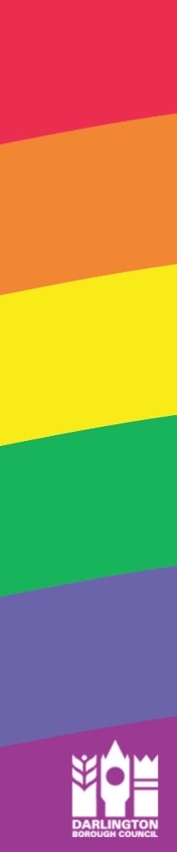
Darlington Pride Consultation: Have your say…

- What do you think the aim of Darlington Pride should be?

- What times do you think it should take place?

- What services / stalls do you think should be invited / promoted?

- What entertainment should be included in the event?

- How do you think we could raise money to support the event?

- Have you any ideas of what events / activities could be part of the day?

- Would you like to be part of the planning / delivery of the event?



Please return to caterine.shaw@darlington.gov.uk

