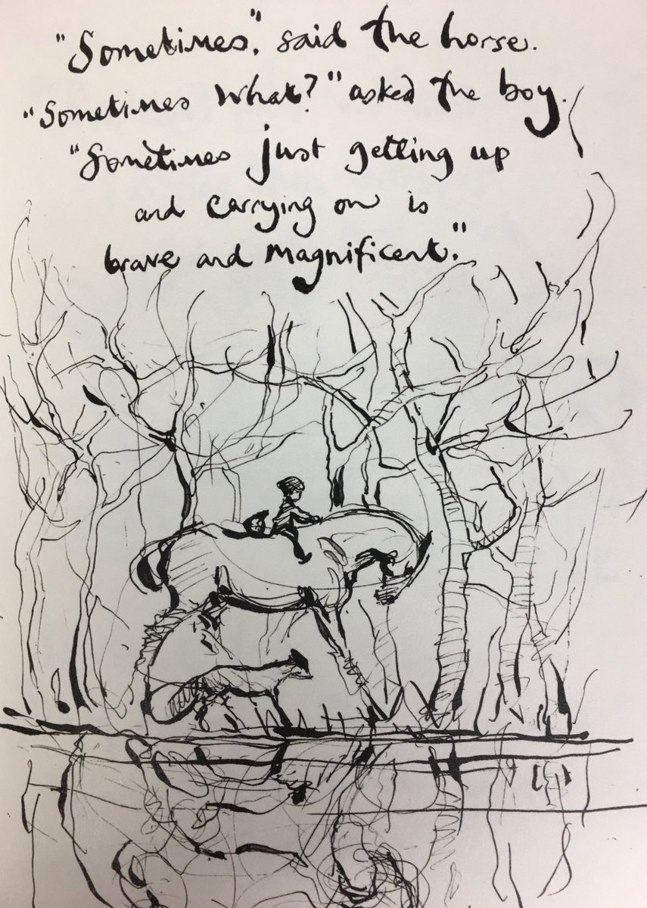
Dear Parents and Carers,
Good morning.
Today is called “Blue Monday” the day in the year that is supposedly the most depressing and in a year like we are having that certainly sounds like a bleak prospect. However, this situation cannot last forever and soon we will be open and things will seem a bit more normal.
In the meantime, I would like to say a huge thank you for all you are doing to help your child/ children with home learning.
Today we shared the year group weekly timetable for your child; this is an overview of all the lessons that will be on-line for your child. We recognise that many of you are balancing work, home-schooling and childcare and want to stress that this work is what is available but do what you can. We made the decision early on to pre-record lessons this is to allow you the freedom to develop your own timetable and fit in teaching around your other commitments. It is also in recognition of the fact that there are often a number of children in each household, sharing a device and therefore live lessons disadvantage these families. We are accompanying lessons with daily drop-ins. These are sessions where the teacher is available on-line to respond to any questions about the learning and offer 1:1 support.
Again, thank you for all you are doing to support your child/ children at this time. We are all in this together and everything is new and different both in school and out. Sometimes you just have to celebrate the small wins and know that you are doing is amazing and appreciated.
Many thanks,

Everyone at West Park Academy

