Darlington Education Strategy Group

Darlington Transition Programme
Key Stage 2 to Key Stage 3
Key Stage 4 to Post-16
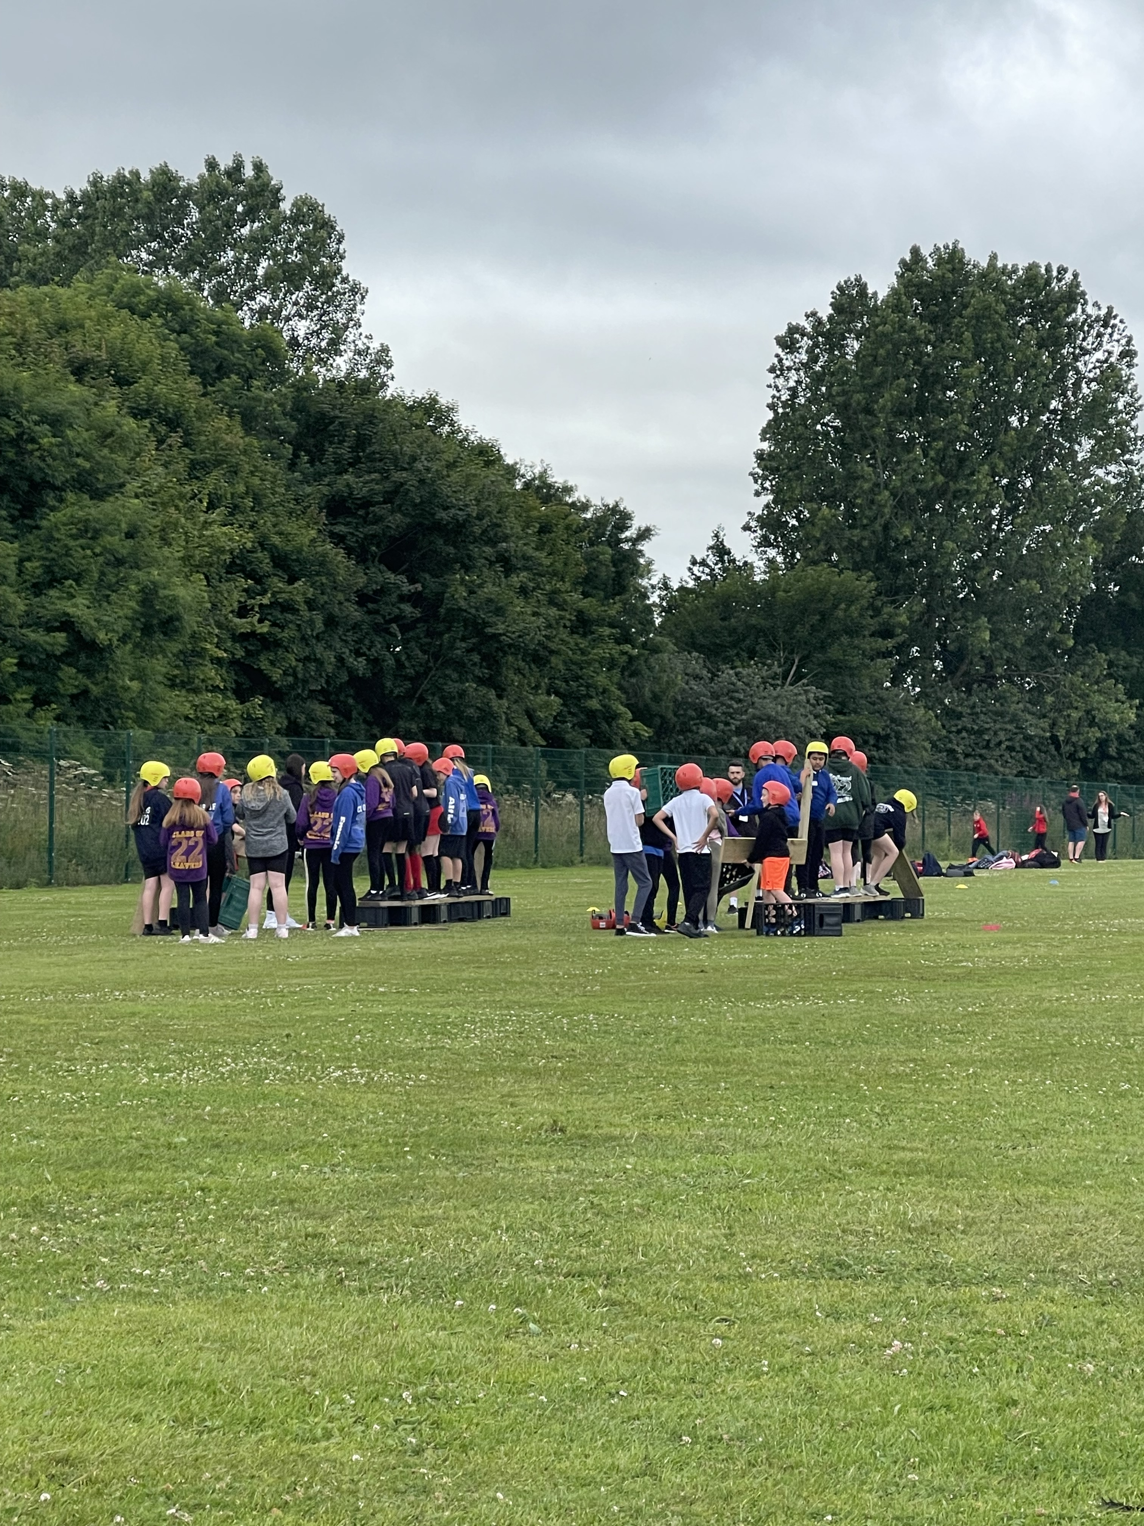

March 2025

Contents
Foreword | 3
Aims | 4
KS2 to KS3 Transition
Pupil Voice | 5
Information Sharing | 11
Pre-Y7 Familiarisation Activities | 13
Building Parental Confidence | 15
Follow-up Four Weeks | 16
Shared Professional Development and Transition Activity | 17
Transition Timeline | 22
KS4 to Post-16 Transition
Transition Support Scheme: Year 11 to Post-16 | 24
Annexes
Annex 1 - Enhanced Transition Support Strategy and Guidance (Pupils with Special Educational Needs or Disabilities) | 26
Annex 2 – Enhanced Transition Support Strategy and Guidance (Pupils with Social Care and Early Help involvement or pupils who have been identified as vulnerable) | 30
Annex 3 - Enhanced Transition Support Strategy and Guidance (Pupils from the Gypsy Roma Traveller community) | 33
Foreword
The Darlington partnership of schools and colleges is committed to a shared responsibility for all children and young people within the local community. Schools, colleges and the local authority work together through the Education Strategy Group, Primary Forum and the 11-19 Partnership supported by a number of sub-groups.
Well managed transitions between education settings that put children and young people at the heart of the process have been identified as a priority for the Education Strategy Group (ESG).
Transition from primary to secondary school is an important milestone in the lives of children and families. Research indicates that ensuring the smoothest possible start to secondary education requires focus on both the pastoral and academic needs of pupils. The Transition Working Group (TWG) support the work of the ESG in this area. Different sub-groups and task and finish groups support with identified areas for development.
An established Transition Support Scheme to help the smooth transition of young people from Darlington schools to post-16 colleges and training providers in Darlington has operated for a number of years.
It is anticipated that this work will continue to evolve with the voice of children and young people at the heart of that development.

Aims
Collectively, Darlington schools and colleges are committed to ensuring that the transition offer for all pupils helps them to settle quickly into their secondary and post-16 education. It is our hope that when children and young people are supported well to manage this change in their lives, this helps to build resilience, a skill that is required into adulthood.
Aims of the Darlington Transition Programme
- Ensure continuity and progression in learning to enable all children and young people to achieve
- Develop the resilience of children and young people when managing change, allowing them to progress and thrive
- Strengthen mutual understanding, partnership working and professional development between phases of education
- Encourage good practice in the transfer of information between partners and provide opportunities for mutual support
- Support retention in education and training into post-16 education and beyond

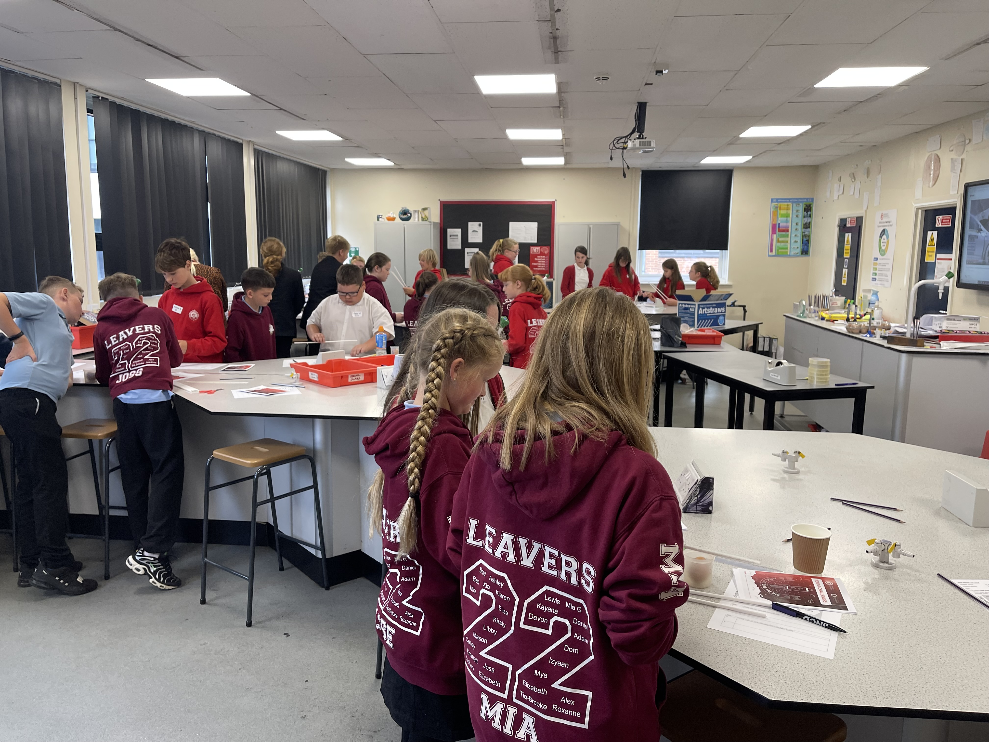

Pupil Voice
Gathering pupil voice to inform transition planning has been an important aspect of the work undertaken by the ESG. Focus group discussions were undertaken by the local authority whereby they sought the views of year 6 pupils in the summer term prior to starting secondary school and the views of year 7 pupils during the first term of secondary school.
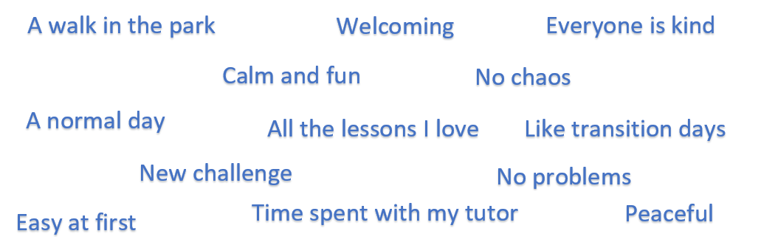
The above is a summary of what year 6 pupils hoped secondary school would be like when asked in summer 2024. They were also asked what they were and were not looking forward to and their responses are listed in the below tables, with a comparison to 2023.
What are you looking forward to?
2024 | 2023
- Getting to know different teachers  - Making new friends  - All wearing the same uniform  - Learning new subjects  - Science investigations  - A new challenge  - More facilities (PE, Drama and Art)  - More outdoor space at lunchtimes  - Variety of enrichment clubs  - Trips abroad  - Walking to school with friends  - More choice of food  - More freedom and independence  - Using my phone outside | - Meeting people and making new friends  - Fresh new start  - More independence and responsibility  - Being more grown up  - Being in a bigger school  - More space  - New and different teachers  - New subjects  - Practical subjects  - Experiments in science  - PE  - After school clubs  - Sports competitions  - Harder work  - The food (canteen style)

What are you not looking forward to?
2024 | 2023
- Being late  - Getting lost  - Loss of equipment e.g. timetable, pencil case  - Multiple teachers and expectations  - Being separated from friends  - Missing my old friends and teachers  - Exams  - Travelling a longer distance to school  - Not having the equipment needed to complete homework  - More homework  - Being the youngest  - Lots of pupils in the corridors  - Negative behaviour in the corridors  - Bullying in the school  - Needing a toilet pass  - Getting into trouble and getting a detention | - Getting lost  - Older pupils  - Bullies  - Remembering everything to bring  - Going in the wrong classroom  - The responsibility  - Being late  - Not being with people who I am used to  - Missing old friends  - Making friends  - Not being liked  - More homework  - Digital homework  - Crowds and how loud it could be  - Getting detentions  - Being told when to go to the toilet  - The big change

The focus groups were also asked about their transition experience. All schools participated in the focus group discussions following the common transition days. Pupils engaged in a comprehensive discussion about their experiences of their new secondary school.
Most pupils attended three transition days. The year 6 pupils were asked about the specific structure and details, including their favourite and least favourite parts. They were also asked to consider any other additional activities they would have liked to experience that they had not had opportunity to access during the transition days.
The pupils discussed their individual experiences which included accessing a wide range of different lessons. They also had opportunities to visit different classrooms and had a tour of the school which was supported by older pupils and staff. Most pupils were introduced to their form teacher although some had not had this opportunity due to changes in staffing.
Favourite parts of the common transition days were the more practical and creative subjects e.g. science, PE, art and practical maths. Pupils particularly enjoyed exploring the different PE facilities schools had to offer and the different sports they could take part in. They voiced how enjoyable the different practical science experiments were and spoke highly about enrichment opportunities including trips and clubs that would be available.
When discussing their least favourite parts of the common transition days, the pupils shared they had limited experience of geography, history and RE lessons and had hoped to experience more of these subjects. Pupils spoke of the individual subject content and how this differs to the topic-based approach of the primary curriculum.
A common theme of the discussions centred around negative behaviour of a small number of pupils during transition times in the corridors which had caused some year 6 pupils to feel nervous. Pupils discussed their concerns about being the youngest within the school and their apprehension of being surrounded by older pupils. Some pupils wished they had spent more time with their form tutor. They shared that they would have preferred to remain in one classroom and to spend more time with individual staff to get to know them better.
Below is a summary of year 7 views about their concerns before and after transition.
Before Transition 2023 Before Transition 2024
- Homework
- Being with different pupils
- Having different teachers
- Knowing who to speak to for help and support
- Remembering what you need to bring to school

- Homework
- Meeting new pupils
- Being with different pupils
- School buildings
- Changing classrooms

Although homework continues to be the top area of concern for pupils, this year there has been a change in pupil concerns, perhaps highlighting some of the social and emotional elements of starting secondary school. Within the focus groups, pupils shared concerns about bullying and pupil behaviour during lunchtimes and breaktimes. As was the same last year, pupils continue to be apprehensive about lunchtimes and this year pupils spoke of the long queues and the impact upon time spent socialising with friends.
Lunchtimes featured heavily in the focus groups discussions and pupils shared concerns regarding the negative behaviour of some pupils and possible overcrowding issues. Pupils also shared their concerns about the limited access to toilets, both at lunchtime and during lessons. However, pupils knew who they could talk to, in order to access the toilets when needed.
‘Changing classrooms’ and ‘lunchtimes and breaktimes’ were other areas of concerns, and these were further analysed within the focus groups. Concerns were also shared about the size of the building and worries pupils had about navigating their way to different classrooms. However, these areas of concern reduced following transition.
After Transition 2023 After Transition 2024
- Homework
- Knowing who to ask for help
- Remembering what you to need to bring
- Being with different children and young people in lessons.
- Lunchtimes and breaktimes and meeting new young people

- Homework
- Knowing who to ask for help
- Behaviour and reward systems
- Lunchtimes
- Changing classrooms

In comparison with the 2023 data, ‘homework’ and ‘knowing who to ask for help’ continues to be the top two areas of concern for pupils after starting secondary school. In comparison to previous years, the concern in all areas decreased following transition.
In the summer of 2024 year 6 pupils were asked how prepared they feel for year 7 and this was compared to the previous year.
How prepared do Year 6 pupils feel for Year 7?
Summer 2024 (51 pupils) Summer 2023 (53 pupils)

98% of the pupils felt ready or somewhat ready for secondary school which is a slight increase upon last year’s figure of 96%.
The number of pupils not feeling ready for secondary school has significantly decreased from 77% in 2022 to 2% in 2024. This improvement reflects the proactive transition work undertaken by Darlington schools, working in partnership across Key Stage 2 and Key Stage 3.
Where pupils did not feel ready, the reasons given were similar to those expressed in previous years which included navigating a large building and concerns about becoming lost. Pupils were also apprehensive about leaving their friends and teachers at primary and having lots of new teachers to get to know.
How prepared do Year 6 pupils feel for English?
Summer 2024 (51 pupils) Summer 2023 (53 pupils)

92% of pupils felt ready or somewhat ready for English at secondary school in comparison to last year’s percentage of 77%. This is an increase of 15% from last year. The number of pupils who do not feel ready is now 8% which is an improvement from 23% in 2023.
Pupils explained the differing approaches to writing from primary to secondary and shared the expectation to begin writing tasks more promptly during the transition days. This contrasted to their primary English lessons where pupils explained they are given more time to engage in sustained creative activities to stimulate ideas for writing.
How prepared do Year 6 pupils feel for Maths?
Summer 2024 (51 pupils) Summer 2023 (53 pupils)

88% of pupils felt ready or somewhat ready for maths at secondary school, compared 89% in 2023. This year, the pupils specifically expressed how they have enjoyed problem solving in maths and having opportunities to apply their learning to real life contexts. They also discussed concerns about maths becoming more challenging at secondary school.
In previous years’ responses, pupils felt more ready for maths than English at secondary school. However, this year there is a significant increase in pupils’ confidence in English.
The work of the ‘Transition in English Group’ where both primary and secondary English subject leads work collaboratively, may be a contributing factor in the increase in pupils feeling prepared for English.

Information Sharing
The exchange of timely and accurate information between schools is an essential component of well managed transition.
Pupil information transfer
All Darlington schools use the ‘Information Transfer Document’ to transfer the main pupil information required by secondary schools to plan for their new pupils.
The document contains up to date contact and basic information that helps to facilitate conversations between the feeder and receiving school.
The Excel document contains 5 sections:
- Contact information
- Welfare and multi-agency information
- Medical and SEND needs
- Additional pupil information
- Assessment information
The Transition Working Group evaluates the document each year to refine and update it after feedback from partners.

Further information on data sharing:
- The Local Authority provides the receiving secondary school with aggregate datasets for allocated pupils via secure means.
- Security procedures:
1) Encryption of personal data on LA devices.
2) Confidentiality and integrity maintained via access controls and staff training/policies and procedures.
3) Compliance with ISO27001, PSN.
- Data is retained by Darlington Borough Council for individual pupils until the end of compulsory school age.
Transition arrangements information
Basecamp is a digital platform where primary and secondary schools share information about transition arrangements. It is used as a central point for all secondary schools to share information made available to parents. Primary colleagues can easily access this so that they are able to answer any queries they receive from year 6 pupils and/or parents.
Basecamp also has a forum where questions can be posted and answered. Primary colleagues have found Basecamp invaluable as a source of information about all the Darlington secondary schools, as they are often the first ‘port of call’ for any questions.

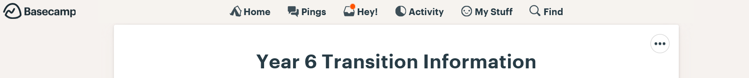

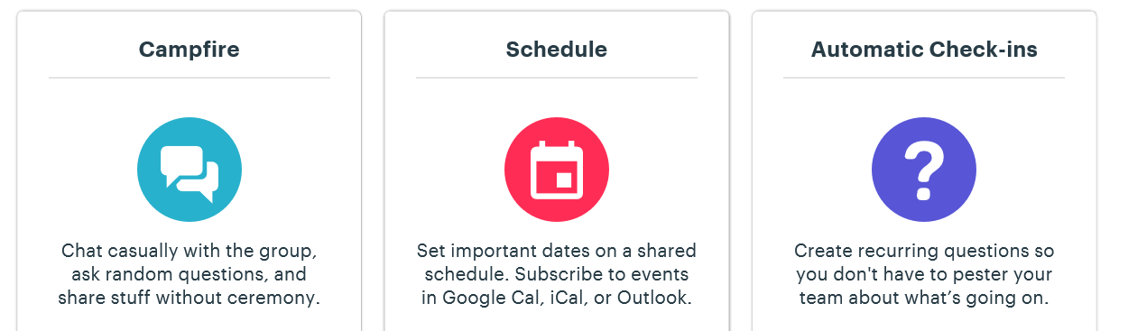

Pre Y7 Familiarisation Activities
Common transition days
Common transition days across all schools in Darlington take place during the last week of June. For the 2024-25 academic year, Haughton Academy, Hummersknott Academy, Hurworth School, Longfield Academy, Polam Hall School, St Aidan’s C of E Academy and Wyvern Academy will provide 3 days on Wednesday 25th, Thursday 26th and Friday 27th June 2025. Carmel College will provide 2 days on Thursday 26th and Friday 27th June 2025 so that sixth form induction can also be accommodated.

The common transition days help pupils to gain a greater understanding of expectations and procedures in their new school. The days are also an opportunity for secondary staff to get to know their prospective pupils including any aspects that may affect their wellbeing.
Information about the new school
Receiving schools help to prepare pupils by ensuring that children and families have information about their new school. This process starts at the year 6 open evenings and communication continues through a range of mechanisms.
As a minimum, all schools ensure that information is shared about the following:
- Behaviour policies
- Contact information for parents
- Equipment needed
- Frequently asked questions
- Homework expectations
- How pupils choose and pay for lunch
- How unstructured periods within school are organised
- Key staff
- First point of contact for pupils to raise issues
- School policy and guidance on use of technology including mobile phones, ‘safe use’ of internet and social networking
- School transport (if applicable)
- Signposting to key links on website
- The layout of the school and how to move around it
- Timetables
- Uniform – including PE kit
Darlington schools have utilised innovative methods such as virtual tours, virtual assemblies, talks, demonstrations and activities to further support transition. These can be particularly helpful for pupils who benefit from enhanced transition.
Enhanced transition support
Some pupils can benefit from an enhanced transition offer. In particular, but not exclusively, this can benefit pupils with special educational needs and disabilities. Annex 1 contains an Enhanced Transition Support Strategy and Guidance document that has been developed collaboratively by a working party which focused specifically on SEND.
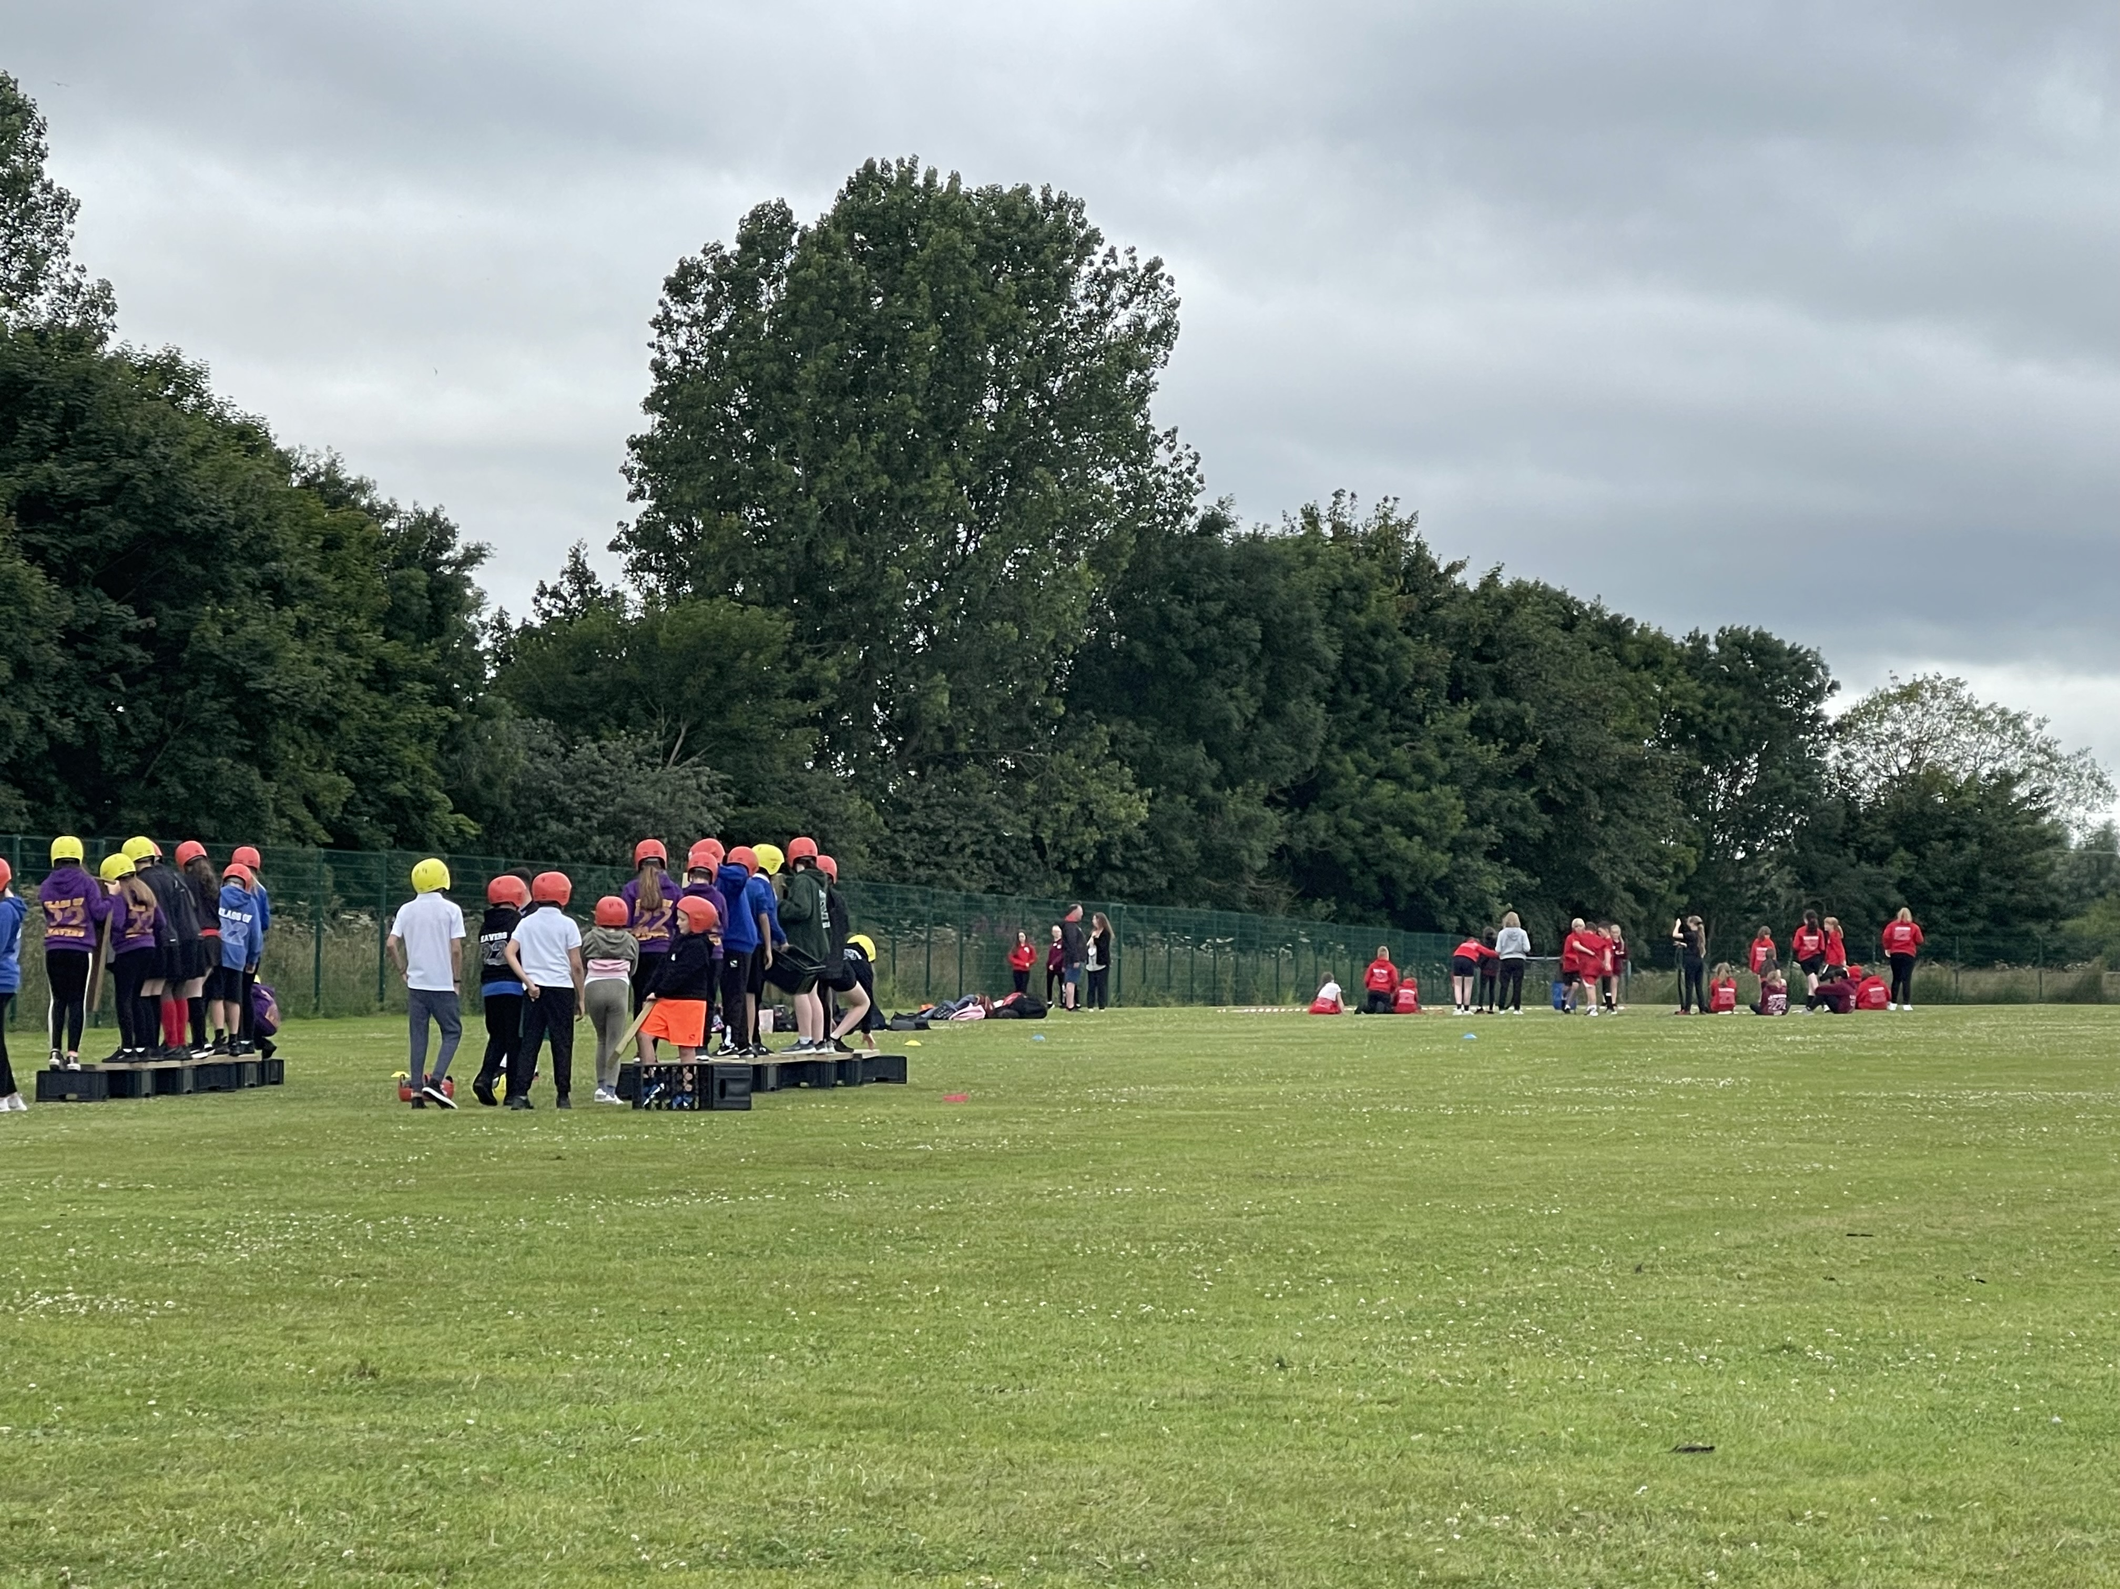

Building Parental Confidence
One way to support a smooth transition to secondary school is by working with parents and carers. Below are some examples of how Darlington secondary schools have involved the pupils’ families.
Coffee Mornings/Evenings
Haughton Academy invite all parents, carers and all families of year 7 pupils to a Macmillan Coffee Morning in October. Year 7 pupils who are Form Captains welcome the families into school and show them along to the hall, as well as running stalls along with Y11 prefects. Other pupils provide a musical accompaniment. Year 7 pupils who have family members coming, go and join them during a lesson and the other pupils access during break. The school also offers a year 7 ‘Coffee and Cake Evening’ in November, and uses this as an opportunity to address any parental queries. The evening starts with a brief presentation and reintroductions to key members of staff such as the SENCO and Head of Year. Heads of department from English and Maths give a brief talk, and then pupils have the opportunity to show their work to parents, while other pupils play music. Form tutors are also available for informal conversations.
SEN Induction event
Carmel College host an event prior to the common transition day for parents of pupils with SEN (including pupils with EHCPs and SEN Support). Parents are introduced to what support for pupils with SEN looks like at secondary school, including interventions and support plans. Staff explain how information about pupil support needs will be shared with staff. Feedback shows that parents have found this very beneficial.
Questionnaires
Some schools send out Parent/Carer Transition Voice questionnaires in order to seek views and this allows them to address any issues that arise.

Follow-up Four Weeks
‘Follow-up Four Weeks’ are the four weeks after the October half term where secondary schools invite primary teachers to reconnect with their former pupils.
Aims
To ensure that there is continuity of learning across KS2 and KS3 by:
- Providing pupils with an opportunity to connect with primary staff to celebrate their move into their new school
- Ensuring colleagues have an opportunity for professional discussion around academic and/or pastoral issues

Each secondary school receives pupils from a number of different primary schools and a ‘one size fits all’ approach would be logistically difficult. Therefore, a range of approaches may be required (see below). Secondary schools invite primary colleagues to ‘follow up’ on different days during the four weeks to ensure no overlap. Individual primary schools may choose to involve year 6 teachers, teaching assistants or members of the senior leadership team as time and capacity allows.
Suggested approaches
1 | Primary staff invited to visit pupils as they participate in lessons and share work | Plus an opportunity for colleagues to discuss academic and/or pastoral needs
2 | Primary staff invited to meet with all their former pupils during the last session of the day | Followed by a twilight for colleagues to discuss academic and/or pastoral needs
3 | A year 7 assembly where representatives from primary schools are invited to celebrate the first half term with their former pupils | Plus an opportunity for colleagues to discuss academic and/or pastoral needs
4 | Class ‘reunion’ for former pupils via Teams facilitated by former teacher | Plus an opportunity for colleagues to discuss academic and/or pastoral needs
5 | Pupils to write a letter to their former teachers, which can be given out as part of the visit or sent to their former school | Plus an opportunity for colleagues to discuss academic and/or pastoral needs
6 | Current year 7 pupils participate in a Q & A session for year 6 pupils, either in-person or virtually | Plus an opportunity for colleagues to discuss academic and/or pastoral needs

Shared Professional Development and Transition Activity
Through shared professional development, Darlington schools aim to strengthen mutual understanding, partnership working and professional development by:
- Building stronger links between the curriculum across different phases
- Further strengthening professional knowledge of cross-phase expectations and understanding of standards
- Continuing to develop professional expertise to support all pupils (including children with additional needs) in the lead up to, during and post transition so that their needs are well met and they are able to access learning and achieve well
Transition working groups
Working groups support the Transition Working Group by focusing on specific areas. In response to pupil voice and with a focus on improvement, schools in Darlington are involved in three projects in 2024/25.
Transition in English Year 6 to Year 7 Working Group
Over the past three years, primary and secondary lead teachers in English have collaborated to strengthen transition in English from KS2 to KS3 to make a difference to primary pupils as they move into their next phase of education. A range of initiatives are now in place to support Year 6 teachers and pupils in the post-SATs period of the summer term, and to improve post-transition experiences for pupils starting year 7. The group created a video to share the work with all Darlington schools. Assessment of the initiatives shows that they have excellent potential to improve outcomes in English post-transition for Darlington’s young people.
The three key initiatives available to support transition in reading in English are:

Year 6
1. Model Transition Lessons Online
A pre-recorded set of 4 on-line lessons which bridge from year 6 to year 7 and introduce explicit vocabulary and questioning styles used in KS3, to be used post-SATs. The lessons build up excitement and anticipation for year 7 English and are designed to be delivered and supported by the year 6 teacher. Not all 4 lessons need to be used, giving flexibility and allowing schools to use them as suits their post-SATs curriculum.
Lessons use vocabulary and techniques which are commonly used in KS3, and help pupils to familiarise themselves with the different way in which English is taught at secondary school. The videos are 10 – 15 minutes in length and open-ended, with pause points for discussion and writing.
1.1. https://www.youtube.com/watch?v=jgDntUmGA3o&t=5s
1.2. https://www.youtube.com/watch?v=KrRv72cvtnU
1.3. https://www.youtube.com/watch?v=eQ4NDdTp6R4
1.4. https://www.youtube.com/watch?v=V6g_RI6mQ4M
2. Scaffolded Bookmark
Introduction and carefully scaffolded use in the second half of the summer term in year 6 of a bookmark which:
· supports pupil response and
· introduces some of the terminology used in KS3 which differs from that used in KS2.
A video has been produced to explain how to use the bookmark effectively for year 6 and year 7 teachers.
https://www.youtube.com/watch?v=V6hoLjcNhAs
The bookmark is available on Base Camp (Y6 Transition Information/Resources)
Year 7
Adapted Assessment
3. English departments at secondary level have introduced careful scaffolding and adaptation of the language used throughout assessment in year 7 to more closely mirror the language and structures of KS2 SATS, leading to improved accuracy of baseline assessment at the beginning of year 7 and improved progress through the year.
The group is currently working on a new resource to support transition in writing, which will be available in summer 2025.
Continuous improvement
Pupil Voice questionnaire
A year 7 questionnaire completed in the second half of the autumn term helps the working group to identify ways in which transition can be improved. Questions address aspects of English lessons in year 6 and year 7.
Results show that the adapted materials and preparatory lessons have helped children to feel more confident in transition in English.
For more information on these initiatives, please e-mail educationtransition@darlington.gov.uk
Transition in Modern Foreign Languages (MFL) Year 6 to Year 7 Working Group
A small group of teachers representing Darlington’s primary and secondary schools are collaborating to look at transition in MFL from KS2 to KS3. Research shows that lack of effective transition practices in MFL can affect engagement with languages in KS3. The group is looking at children’s attitudes to learning languages and ways to build cultural capital as well as engage and enthuse children with language learning. The group seeks to strengthen transition in MFL for Y6 and Y7 pupils.
With these aims in mind, a new website, Darlingo, has been created to house resources and share links and good practice between Darlington schools and further afield. The group has produced a set of high-quality lessons aimed at building cultural capital and enthusiasm for language learning. These lessons come with comprehensive teaching notes and can be easily delivered by the non-specialist teacher. Following a pilot in summer 2024, these materials are now free for all to access here.
For more information on transition in MFL, please e-mail educationtransition@darlington.gov.uk
Emotionally Based School Avoidance (EBSA) at Transition Working Group
In 2023, the Transition Working Group identified EBSA as a priority area and established an EBSA at Transition Task Group. A pilot programme based at Clifton House was developed for Y6 students who are either identified as impacted by Emotionally Based School Avoidance (EBSA) or are at risk of being impacted.
The Steps to Secondary Success pilot programme built relationships with Y6 pupils in their own primary schools before pupils attended Clifton House for two afternoons a week after Easter. Pupils participated in the Spark Resilience programme and bespoke activities based upon the EPS EBSA guidance and ELSA approaches.
After May half term, pupils visited secondary schools to meet key secondary school staff, to introduce themselves and participate in Q&A sessions.
Post-transition to Y7, pupils returned to Clifton House for one afternoon per week. This supported an extended transition to secondary school. The programme continued to develop social and emotional aspects of the curriculum and address any worries or concerns raised by the children about their transition process.
It was considered vital to the success of the programme that parents were involved from the outset. Early Help colleagues delivered three sessions for parents. These sessions explored the parent’s own experiences of education, strategies and practical techniques to support improved school attendance and parental involvement in education.
The following contributed to the success of the programme:
- Identification of EBSA risk factors (education / social care)
- Input from a key person, external to the school, providing regular check-ins
- Small group work
- Engagement in the home as required
- Appropriate curriculum
- Joint planning between primary and secondary schools
- Support from social care to ensure that family circumstances and dynamics are considered

Primary to Secondary Transition – current research
Below are some links to articles/websites/blogs which may be useful for further reading.
EEF Blog: Supporting pupils through transitions – a trio of… | EEF (educationendowmentfoundation.org.uk)
Primary to secondary school transitions: systematic literature review - gov.scot (www.gov.scot)
Facilitating a successful transition to secondary school:(how) does it work? A systematic literature review. Van Rens, M., Haelermans, C., Groot, W., Van den Brink, H. M. (2018) Adolescent Research Review, 3(1), 43 – 56.
Journal of Education & Social Sciences | Iqra University Primary-Secondary School Transition: Impacts and Opportunities for Adjustment Joanne Harris et al. (2020) Journal of Education & Social Sciences Volume 8

Timeline
Below is a summary of key points for transition activity throughout the academic year.
Autumn Term
 | Year 6 Pupils |  | Year 7 Pupils |  | Professionals
September | Year 6 Open Evenings |  |  |  | Year 5/6 SENCO Update at SENCO network to encourage and facilitate enhanced support  Year 6 EHC plan reviews held for pupils and placement for year 7 identified
October
November |  |  | Follow Up Four Weeks  Year 7 Pupil Voice Focus Groups
December
Spring Term
 |  | Year 6 Pupils |  | Year 7 Pupils |  | Professionals
January |  |  |  |  |  | Information Transfer Document sent to primary schools – deadline for return 31st January 2025
February |  |  |  |  |  | Deadline for EHC plan issue for secondary school places
March |  | National Offer Day |  |  |  | Transition discussions between schools begin (SENCOs, Transition leads and year 6 teachers, DSLs and external agencies as appropriate)  Secondary schools upload transition information to Basecamp as it becomes available  Information Transfer Document sent to secondary schools by 21st March 2025 (from Performance Team)
Summer Term
 |  | Year 6 Pupils |  | Year 7 Pupils |  | Professionals
April |  |  |  |  |  | Transition discussions between schools (SENCOs, Transition leads and year 6 teachers, DSLs and external agencies as appropriate) continue  Secondary schools upload transition information to Basecamp as it becomes available
May
June |  | Year 6 Pupil Voice Focus Groups  Common Transition Days
July |  |  |  |  |  | Secondary schools can download SAT results from the Primary Assessment Gateway.

Transition Support Scheme: Year 11 to Post-16
This collaborative scheme has operated successfully for many years. The scheme aims to support young people as they move from pre-16 to post-16 education in Darlington, and to support retention during the first few weeks of post-16 education. The scheme involves Darlington secondary schools, Darlington College, Queen Elizabeth Sixth Form College, Carmel College Sixth Form and the Darlington Borough Council Learning & Skills Service.
The Local Authority pre-populates a transition document with information held centrally regarding year 10 pupils, after the May school census. This document contains information in the following 5 sections that helps to facilitate conversations between the school and post-16 provider:
- Basic pupil identification information
- Academic information
- Welfare and multi-agency information
- Medical and SEND needs
- Additional pupil information
In the autumn term, Transition Leads in secondary schools gather additional information to help support the young person as they transition to post-16. Information is also collected in school for any new Year 11s who joined school after the May census.
The colleges provide the Local Authority with a list of Year 11 applicants.
In the spring term, the Local Authority arranges 14 meetings: 7 with Darlington College and a secondary school, and 7 with QE College and a secondary school. Meetings are chaired by the Local Authority and attended by Lead Mentors / safeguarding staff / learning support staff / SENCOs from the relevant college, and appropriate school staff such as Head of Year, SENCO, mentor, pastoral lead and / or counsellor who know the students well.
The meetings identify any support needs for each of the students who will join the colleges in September. This enables colleges to provide bespoke transitional support during the summer, at bridging and connecting to college days and during the first few weeks at college.
Smaller meetings are arranged with the Home and Hospital Teaching Service, Rise Carr College and Beaumont Hill Academy to share information about students progressing to Darlington College, QE or Learning & Skills to enable the students to receive the most appropriate transition support.
Each year the scheme is reviewed by schools and post-16 providers to refine, update and continually improve.

Annex 1
Enhanced Transition Support Strategy and Guidance
(Pupils with Special Educational Needs or Disabilities)
A sense of belonging, relational connections and feeling included is of paramount importance for pupils in Darlington. This is why carefully considering the needs of individual children and supporting transition from one phase of their lives to another is so vital.
Moving from one school/setting/class to another can be stressful, and while all children and young people benefit from a positive transition, some who have additional needs may find transitions more challenging than their peers and will require enhanced support.
Primary and secondary colleagues should work in tandem with the suggested strategies below and agree with parents and carers what each of the 3 parties involved will do in the settings and in the home to support transition.
Consideration should be given to the following:
- The importance of establishing good communication across all relevant agencies involved
- The need to share information with all relevant agencies working with the child or young person
- Schools should offer support to parents for joint conversations regarding any emerging concerns
- The local authority and specialists should work with the family during reviews in Y5 and Y6 to identify what support is required to meet the needs outlined in Education, Health and Care (EHC) plans. Secondary SENCOs should attend reviews in Y5 and Y6 where requested
- The importance of contact with all relevant services as early as possible to identify and plan for needs e.g. specialist equipment, therapy needs, physical adaptations to the environment, mobility and care needs, communication needs and curriculum needs

The table below is designed for use in reviews, transition meetings, or meetings with parents. It aims to secure an understanding of what support each party will undertake as part of the enhanced transition process.
Secondary Schools | Primary Schools | Parents, carers, children or young people
- Start early – pupils with more significant needs may need a longer, phased transition period that builds over time. Contact primary feeder schools and offer to attend pertinent Annual or IEP Review meetings for students with SEN or additional needs.  - Develop joint-school activities between Year 6 primary and Year 7 secondary school pupils e.g. sporting or social events, shared trips.  - Ensure the secondary school SENCO and TAs visit feeder primary schools to meet young people and their parents/carers.  - Offer sessions for parents/carers of pupils with SEN or additional needs at Admissions Open Evenings, with additional opportunities at later dates for potential pupils.  - Ensure the secondary school SENCO acts as a transition coordinator to liaise with primary school staff, parents and the pupil themselves.  - Ensure the secondary school SENCO prepares notes about each pupil with SEN to share with staff – for example, focusing on their learning needs, responses to disabilities, reasonable adjustments that need to be made – and prepares a ‘student information sheet’, ‘passport’ or a ‘pupil profile’ with photo and information about useful learning strategies to go to all subject teachers and TAs.  - Provide clear and accessible guidance for new pupils, ensuring that you:  - summarise rules and expectations  - explain timetables  - provide a map of the school  - remind pupils about equipment needed  - set out homework expectations  - introduce staff and other key people  - answer ‘frequently asked questions’  - identify people students can go to with worries or problems (and where to find them)  - clarify school policy and guidance on use of technology including mobile phones, ‘safe use’ of internet and social networking  - offer some ‘key’ links to the schools website – e.g. school rules, homework tasks, lunch menus, campus map  - For pupils with additional needs, run a series of ‘Primary Day’ visits – for groups and individuals where needed, including ‘taster’ days with sample lessons, lunchtimes, social activities etc – for some students, this might mean up to a day a week for a term or longer. | - Ensure that primary school records (academic, personal and social, relating to IEP targets etc) are in a form that will be useful and relevant in the secondary context. Brief ‘pupil profiles’ of key information are a valuable start to sharing.  - Plan visits to the secondary school early – identify those who may need several visits or phased transitions. Some pupils will benefit from starting transition planning in Year 5.  - Invite secondary SENCOs to meet parents/carers in the familiar primary school setting.  - Run regular ‘Circle Time’ sessions focused on the transfer to secondary school – breaking down the myths and concerns and clarifying the genuine expectations.  - Explore similarities and differences and potential ‘new’ terminology.  - Introduce a homework planner and set regular homework tasks – scaffold skill development to organise and complete this work on time.  - Encourage pupils to use their timetables to identify and plan ahead – what equipment or preparation will they need? When do they need to do this? Some useful apps are available to support this e.g. 4KidCal.  - Introduce opportunities for pupils to work with others they don’t know so well – either in class or across school.  - Offer pastoral support and introduce specific techniques to self-manage anxiety e.g. breathing and relaxation techniques, easy-read or comic strip scenarios to problem-solve common worries they may experience in the secondary school context.  - Establish collaborative working with secondary staff to look at opportunities for after school ‘transition’ clubs or holiday schemes and projects on the new secondary school site. | - Speak to your child’s teacher or SENCO to ask about the transition visits. If you think your child needs extra visits, talk to the teacher or SENCO about it.  - Look at the website for the new secondary school. Find out if you can access a map of the school, examples of timetables, lists of school clubs and lunch menus to familiarise your son or daughter with the school.  - Find out if there is a ‘safe place’ where your child can go to if they feel worried or if there is a particular member of staff they can talk to.  - During the summer holidays listen to your son or daughter’s concerns if they have them and suggest ideas to help them cope. For example, if they worry about getting lost, make sure they have a map with them or know they can ask a teacher. Or if they worry about not having something to do at lunchtime suggest they go to the library or find out if there is a ‘safe place’ at the school.  - Make sure you have a timetable at home to help your child prepare for school the next day.  - Find out what activities and clubs are available for your son or daughter.  - In case of emergencies, make sure they have some money or credit on their mobile phone.  - Ask for the dates of parent evenings and review meetings.  - If school transport is not provided, start planning and practising the journey to school during school holidays.  - If they are not used to using a library, start to familiarise them with your local library – introduce them to using the computers and learn how to locate books on topics of interest.  - Consider when you will take your holidays – some people may prefer to be at home for a week or two to begin to prepare for starting a new school, rather than rush from a holiday straight into the school term.

Annex 2
Enhanced Transition Support Strategy and Guidance
(Pupils with Social Care and Early Help involvement or pupils who have been identified as vulnerable)

To support the enhanced transition for vulnerable children transitioning from primary (year 6) to secondary school (year 7) it is vital that information is shared in a timely manner to plan the right support for each child and to start to build effective relationships between the child, parents/carers and the new staff within the secondary school.
To support these aims both primary and secondary school staff and relevant agencies should consider the following:
- The need for all agencies working with a child to share information early.
- The promotion of good communication between child, parents/carers and other agencies.
- The need to ensure that pupil voice is listened to, including fear and worries about transition.
- The need to have a particular focus on children with social workers, including having knowledge of these pupils’ academic attainment.
- For all agencies and school staff to have a culture of high aspirations for this cohort.
Information below aims to support each party in their role in supporting the enhanced transition process.
Primary School Staff
- Transition transfer information to include details of children who have Children’s Social Care and Early Help Services involvement or have been identified as vulnerable.
- To share relevant, factual, accurate information securely with the DSL or named safeguarding team member at the secondary school, including the name of the allocated Early Help or Social worker, the level of support (i.e. Early Help, Child Protection, Child in Need (CIN), Looked After Child), and the intervention in place.
- Invite secondary representative to future review meetings (core groups, CIN, multi-agencies meetings, team around the family meetings (TAF), Looked After reviews).
- To share child’s and parents’ and carers’ concerns or worries if applicable.
- If school is leading on an Early Help assessment, the primary lead to case is handed over to TAF lead in secondary school, sharing relevant information and documentation.
- Relevant primary staff member to attend review meetings in autumn term to support child and parent, if required.
- To alert secondary DSL or relevant staff member of any children who have become involved with services during the summer term and not included on the transition spreadsheet.
- Early Help assessment led by the primary school should be transferred to an appropriate lead in the secondary school (with parental consent) so that the family can continue to be supported in their new setting. A copy of the assessment and all TAF plans should be shared with the new lead professional and a handover TAF meeting should take place with the family before the child’s start date. Primary Lead to attend first TAF meeting held in autumn term if required. Early Help assessments should not be closed prior to secondary transition if issues are still ongoing.
- Transfer CPOMS data to secondary school on first day of the autumn term.
Secondary School Staff
- DSL or relevant safeguarding team member to meet with primary DSL or relevant safeguarding team member to gain information regarding vulnerable children and those children with Children’s Social Care and Early Help involvement.
- DSL or appropriate staff member to attend reviewing meetings (core groups, CIN, TAF, PEPS and LAC reviews) during the summer term and during summer holiday period if required.
- To offer to meet with child, parents/carers to gain the voice of child and complete additional transition activities as required.
- Offer child and family a key point of contact / trusted adult in secondary school including contact details.
- CPOMS data to be reviewed and for DSL or appropriate staff member to share relevant safeguarding information with year group lead, tutor, SENCO, mental health lead and other key staff in school as required.
- To utilise primary school’s knowledge of child and family during year 7 when child is experiencing issues. For example, primary to share strategies used in past to encourage school attendance.

Social Workers and Early Help Practitioners
- To identify those children who will be transitioning to secondary school in the autumn term and ensure that the parent or carer has applied for a secondary school place by the October deadline.
- After school offer day, beginning of March to gain consent from parents/carers for relevant secondary school staff member to be invited to attend multi-agency meetings during the summer term.
- Invite secondary school DSL or relevant staff member to attend review meetings (TAF, CIN, core groups, care team meetings, PEPS or LAC reviews) during the summer term and during the 6 weeks holiday period if required.
- To ensure transition plans are discussed at review meetings, set specific actions for transition period and for all multi-agencies o promote good outcomes for child during this key period including the first months of the child starting secondary education in the autumn term.
- Io include transition within assessments and in family plans in the summer and autumn term if required, with a multi-agency input. For example, school attendance strategies.
- Where agencies are considering closing a child to services before the transition date, they must use a multi-agency meeting to adequately risk-assess the impact of this decision at a key transition point in the child’s life. School staff must be invited and involved in decision making and meetings held during the summer holiday period.
Key information
Information sharing
Information sharing is essential for effective safeguarding and promoting the welfare of children. It is a key factor identified in many serious case reviews. Information shared must be relevant, factual, accurate and shared securely.
During this enhanced transition period it is appropriate to share information with the new school in advance of a child leaving. Information shared would allow the new school to continue supporting victims of abuse and have support in place for when the child arrives. (Keeping Children safe in Education 2020 p100 - 101).
Transfer of child protection file
The DSL should ensure child protection files are transferred to the new school as soon as possible in the autumn term. This information should be transferred separately from the main pupil file, ensuring secure transit, and confirmation of receipt should be obtained.
Receiving schools should ensure key staff such as pastoral and mental health leads and SENCOs are aware as required.
CPOMs transfer of data
Primary school that hold safeguarding records on CPOMS should transfer data by the first day of the autumn term.

Annex 3
Enhanced Transition Support Strategy and Guidance
(Pupils from the Gypsy Roma Traveller community)

Moving from primary to secondary school for the Gypsy Roma Traveller (GRT) community is a huge step. Many parents may not have had any experience of secondary school or may have had poor experiences. A significant number of pupils from the GRT community have historically left formal education at the end of year 6, choosing Elective Home Education (EHE). For those that do attend secondary school there may be a multitude of barriers that stand in the way of successful transition.
The table below provides recommendations on transition support and activity. The Traveller Education Advisory Service (TEAS) are able to support with transition activities as detailed below.
Secondary School | Primary School | Parents/carers/children or young people
Available Support
Implement a buddy system for year 7 pupils from the GRT community. This buddy system to continue through year 7, year 8 and beyond.  TEAS to support secondary staff by providing continuous professional development on cultural awareness and removing barriers to education for pupils and parents.  Nominate a member of staff to be a point of contact for parents and for home/school liaison. Communication to continue with TEAS as additional support for home/school liaison.  Set up half termly mentoring with TEAS within school to provide a link between family, school and specialist service.  TEAS to meet with a member of staff to discuss destination information to identify potential ‘success stories’ to share with the community. | Engage in early conversations with pupils from the GRT community to understand and identify which pupils are likely to go onto secondary school. Primary schools to contact TEAS to share knowledge of any pupils from the GRT community that are intending to apply for a secondary place so that a support package can be implemented.  TEAS to support a mentoring system for year 6 Pupils from the GRT community who are going on to secondary school.  TEAS to deliver circle time sessions to pupils from the GRT community in order to address any concerns or worries.  TEAS to work with primary school to provide opportunities to liaise with parents.  Provide opportunities for current secondary pupils from the GRT community to visit primary schools where pupils from the GRT community have been identified as intending to go onto Year 7. This would provide the opportunity to discuss transition with peers to alleviate fears and anxieties and show that transition can be productive and successful. | TEAS to work alongside primary schools to engage with the parents and discuss worries and issues as they arise. This could be through informal parent meetings within school or as a home visit.  Pupils from the GRT community and parents to undertake early, extra visits to secondary schools supported by TEAS.  Extra visits by pupils from the GRT community to secondary school in order to familiarise themselves with a larger school environment with the support of a known/familiar adult.  TEAS to support pupils and parents to source equipment needed and understand school timetables.

