Dear Parent/Guardian
Pupil Premium
Our school receives funding from the Government to cover the costs of providing education. The school receives additional funding (known as the pupil premium) for pupils whose families receive certain benefits.
It is in all our interests that we bring in as much money as we can to support our school and ensure all of our children get the best possible education. To help your child and your school, we can do a very quick eligibility check for this additional funding via Durham County Council. In order to do this we require some simple information.
For the whole of the time your child is in our school this is the only information we need to check unless your surname changes. Please rest assured that the information you provide is confidential and will be treated with the strictest confidence and safe keeping.
If you could provide the information on the form below, sign and return it to school, we will do the rest.
Yours sincerely
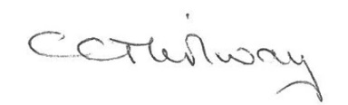
Mrs Thirlway
Office Manager
…………………………………………………………………………………………………………

Pupil Premium Entitlement Verification Check

Name of pupil(s).....................................................................................Year ........................

Surname of Parent/Guardian..................................................................................................

National Insurance No:

Date of Birth of parent/guardian: ..........................................................................................

I hereby give consent to check for Free School Meals eligibility, via Durham County Council and the Department for Education’s online service. I understand that it is my responsibility to inform the school if I no longer receive the relevant benefit.

Parent/Guardian Signature………………………………………….Date…………………

